Task 5 Report – Object Extraction (Back Door of Container)

Objective:
To extract the back door of a container from the provided image using both traditional and deep learning approaches, with a preference toward adaptable, automated methods.

Methods Tried:
Deep Learning – YOLOv8 Segmentation With Roboflow:
Approach A: Semantic Segmentation Pipeline
- Data Preparation:
  - Several container images were annotated on Roboflow using polygon masks around the back door region.
- Model Training:
  - A YOLOv8 segmentation model was trained on the annotated dataset.
- Prediction & Cropping:
  - The model was run on the target image.
  - The resulting segmentation mask was applied and the masked region (back door) was cropped automatically.
- Outcome: Very accurate and clean extraction of the container door with minimum noise.

Approach B: Direct Bounding Box Labelling + Cropping
- Data:
  - A bounding box annotation was manually drawn around the back door.
- Steps:
  - The labeled region was directly extracted from the image using the coordinates.
- Outcome:
  - Fast and effective method for known scenes but lacks flexibility for complex or new container shapes.

Final Output:
- The extracted door image was successfully saved using both approaches.
- Segmentation provided better adaptability, while bounding box was simpler for fast use-cases.

Observations:
- YOLOv8 segmentation gives high precision but requires some training data.
- Manual bounding box labeling is effective but It won't work if the number of photos is very large.
- More annotated images would likely improve segmentation model performance significantly, especially for challenging edge cases or varied container types.

Comparison the result:

Original Image:
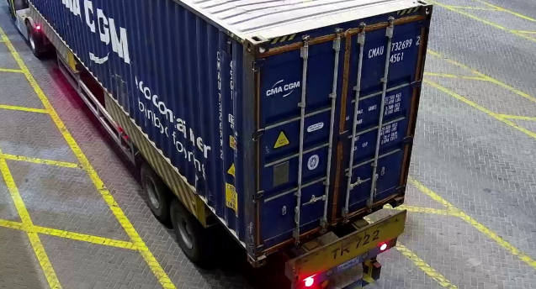

Yolov8_Seg
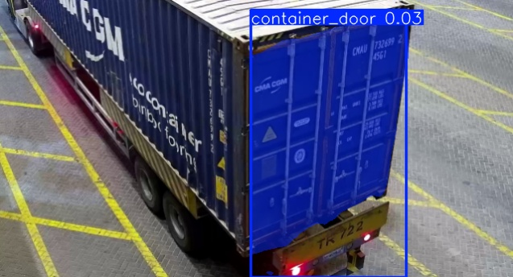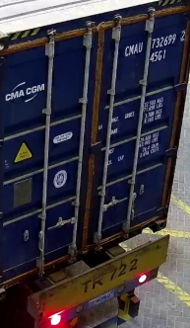

Labelling + Cropping

